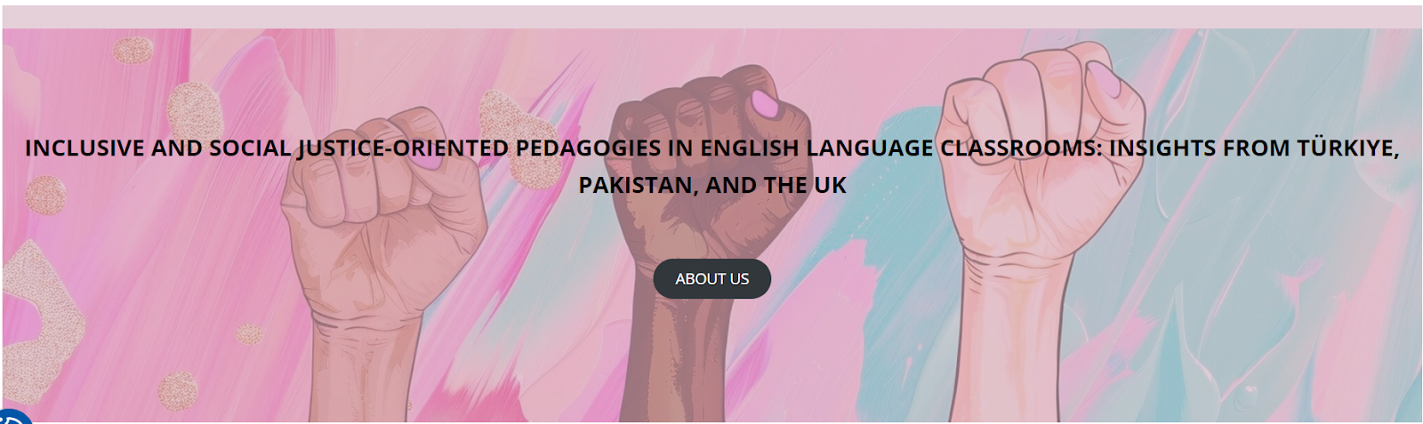

Workshops at the University of Stirling, UK
22-23 February 2025

LESSON PLAN TEMPLATE

School/Institution:
Grade/Level:
Language:
Course:

Rationale Statement ___________________________________________________________________________________________________________________________________________________________________________________________________________________________________________________________________________________________________________________________________________________________________________________________________________________________________________________________________________________________________________________________________________________________________________________________________________________________________________________________________________________________________

Objectives
Content Objectives | Language Objectives
Social Justice Objectives

Procedures
Pre-activities: Brief description | Time frame | Objective(s) targeted
During activities: Brief description | Time frame | Objective(s) targeted
Post-activities: Brief description | Time frame | Objective(s) targeted

Materials

Formative Assessment

Differentiation

Reflection

LESSON PLAN REVIEW CHECKLIST

✓ Yes X No NA Not applicable

_____ Are there language, content, and social justice objectives?
_____ Do the activities, materials, and tasks align with/support the learning objectives?
_____ Are there problem-posing, reflective, text analysis, and action-oriented activities?
_____ Are there any authentic and multimodal texts used?
_____ Do group/pair tasks foster negotiation of meaning and discussion of ideas?
_____ Does the lesson promote an equitable perspective towards different identities and cultures?
_____ Does the lesson encourage learners to investigate social, economic, and political issues?
_____ Does the lesson reflect multiple perspectives in ways that challenge the status quo?
_____ Does the lesson include topics related to students’ backgrounds and concerns related to their lives and communities?
_____ Is differentiation used? If not, how could it be incorporated?
_____ Is there a formative assessment plan? If not, how could it be added?

