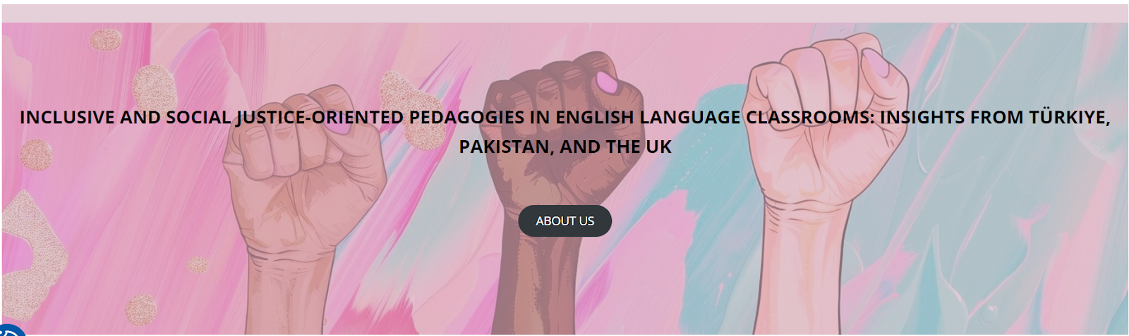
Workshops at the University of Stirling, UK
22-23 February 2025

LESSON PLAN TEMPLATE

School/Institution:
Grade/Level:
Language:
Course:

Rationale Statement
Briefly provide information on the significance of the topic, your own positionality in regards to selecting this particular topic, shaping pedagogical frameworks etc. In short, explain why and how your language learners will study this topic in your classroom.

Objectives
Content Objectives | Language Objectives
Social Justice Objectives

Procedures
Pre-activities: Brief description | Time frame | Objective(s) targeted
During activities: Brief description | Time frame | Objective(s) targeted
Post-activities: Brief description | Time frame | Objective(s) targeted

Materials
List here any authentic and multimodal materials you will use in this lesson plan.

Formative Assessment
Describe how you will monitor student learning throughout the lesson.

Differentiation
Describe if you will be differentiating course content, activities, or assessments according to learner needs, interests, and developmental levels.

Reflection
If you get a chance to teach this lesson plan, reflect on the strengths and weaknesses of your lesson. How did it go? What would you do differently? Alternatively, use the checklist below to discuss this lesson’s strengths, weaknesses, and affordances for student learning and potential threats/pitfalls.

LESSON PLAN REVIEW CHECKLIST

✓ Yes X No NA Not applicable

_____ Are there language, content, and social justice objectives?
_____ Do the activities, materials, and tasks align with/support the learning objectives?
_____ Are there problem-posing, reflective, text analysis, and action-oriented activities?
_____ Are there any authentic and multimodal texts used?
_____ Do group/pair tasks foster negotiation of meaning and discussion of ideas?
_____ Does the lesson promote an equitable perspective towards different identities and cultures?
_____ Does the lesson encourage learners to investigate social, economic, and political issues?
_____ Does the lesson reflect multiple perspectives in ways that challenge the status quo?
_____ Does the lesson include topics related to students’ backgrounds and concerns related to their lives and communities?
_____ Is differentiation used? If not, how could it be incorporated?
_____ Is there a formative assessment plan? If not, how could it be added?

