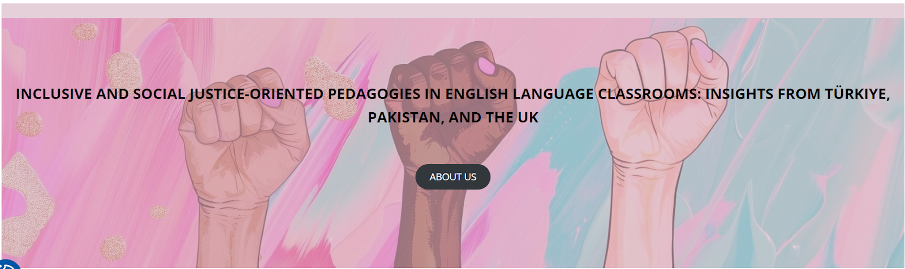

Workshops at the University of Stirling, UK
22-23 February 2025

LESSON PLAN: Climate Justice

School/Institution: Sustainable Future Academy
Grade/Level: Senior High School (15-18) - CEFR B2
Language: Multilingual (Chinese and Vietnamese)
Course: English Class
Duration: 60 minutes

Rationale Statement
Climate justice connects environmental issues with social inequality, making it a powerful topic for critical thinking and language development. It highlights how marginalized communities—often least responsible for climate change—face its worst impacts, from extreme weather to displacement. By analysing this topic through an authentic text, students build vocabulary around fairness, responsibility, and global action while practising persuasive language. The topic resonates with teens as it encourages them to articulate opinions about their future—key for engagement in B2-level speaking tasks—while also fostering critical thinking, collaboration, and advocacy, empowering students to become global citizens.

Objectives
Content Objectives | Language Objectives
- To examine and understand the impacts of global climate change on the ecosystem and the community. | - To review key vocabulary related to climate change and social justice.  - To develop reading skills in predicting, skimming and scanning.
Social Justice Objectives
- To enhance students’ awareness of climate justice and its impact on marginalised communities.
- To analyse how socio-economic status influences vulnerability to climate disasters.
- To develop empathy and advocacy skills by understanding the struggles of communities affected by climate change.
- To encourage responsible actions and activism in support of sustainable and equitable climate solutions.

Procedures
Pre-activities | Time frame | Objective(s) targeted
T greets Ss and asks about the recent weather.  - If pleasant, T asks if it is pleasant everywhere.  - T asks Ss why the weather might be unpleasant.  On Mentimeter, T asks Ss to share what they think of when they hear the term CLIMATE JUSTICE.  T does a quick reflection of the results.  T shows a collection of photos from the article (Appendix A).  T asks Ss to discuss in pairs about what they think is happening based on the pictures.  Ss share their predictions with the whole class.  T writes the predictions on the board. | 10 mins | To generate interest in the topic and set the scene for the lesson.
T asks Ss to complete Part 1 of the vocabulary exercise (Appendix B) to check their knowledge and understanding.  Ss complete on their own, then do peer-checking.  T displays answers on the screen and discusses words that seem problematic.  T then asks Ss to proceed to Part 2, and allows Ss to work in pairs if needed. | 10 mins | To pre-teach key vocabulary needed to help Ss complete the task.
During activities | Time frame | Objective(s) targeted
T hands out the article on climate justice and asks Ss to skim it to check whether their initial predictions from the pictures were correct.  In pairs, Ss discuss their initial findings. | 5 mins | To develop Ss’ reading for global understanding.
T asks Ss to read the article and highlight potential answers for the following question:  ‘Find 3 examples of how climate change worsens inequality.’  Ss discuss their answers in pairs, then with the whole class. | 15 mins | To develop scanning for specific information.
Post-activities | Time frame | Objective(s) targeted
T presents the following scenario:  ‘Our school would like to become a more environmentally just and responsible institution. It requires an action plan to implement over the next five years. As a committee of stakeholders, you will meet, discuss and challenge ideas, then form the action plan.’  T assigns Ss to a role based on Appendix C.  Ss of each role form a group to discuss their ideas and opinions.  As a whole class, Ss engage in a debate to settle on the best action. T acts as moderator if needed. | 20 mins | To further personalise the topic and allow opportunity for productive practice.

Resource
- Nakat, G. (2023) ‘Climate justice and social justice: two sides of the same coin’, Greenpeace International, 21 February. Available at: https://www.greenpeace.org/international/story/58334/climate-justice-and-social-justice-two-sides-of-the-same-coin/ (Accessed: 16 September 2025).

Appendix A
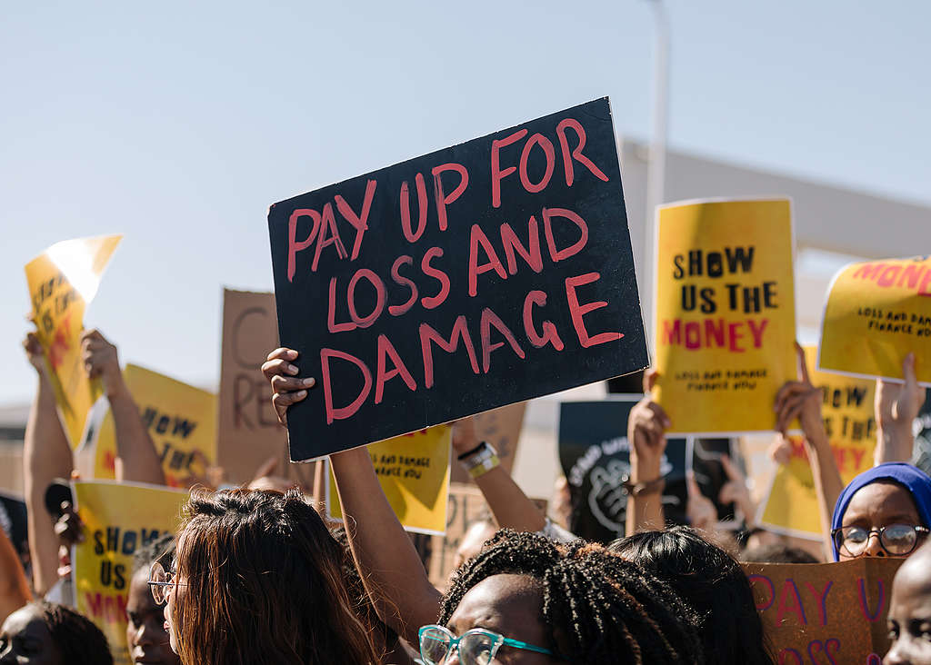
(Image source: Marie Jacquemin / Greenpeace)

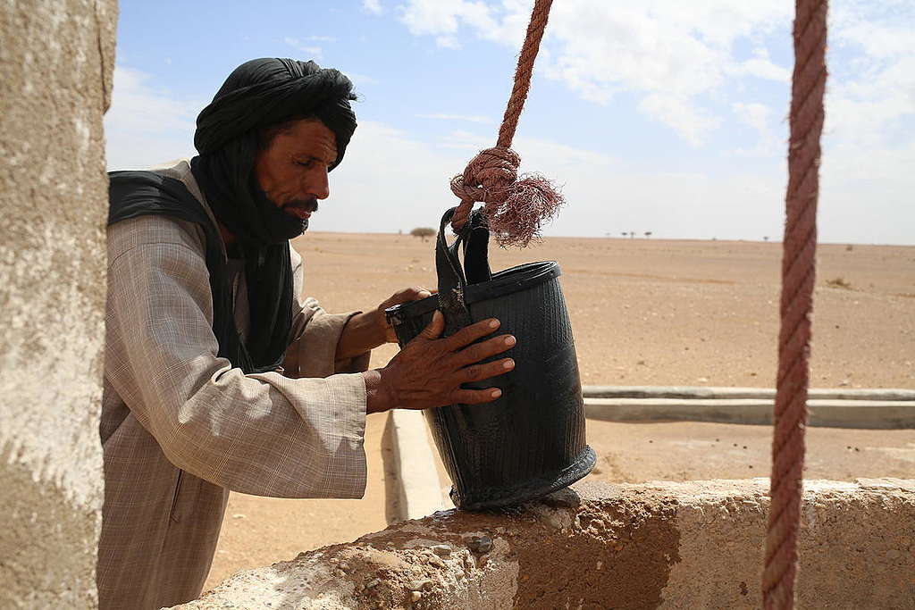
(Image source: Therese di Campo / Greenpeace)

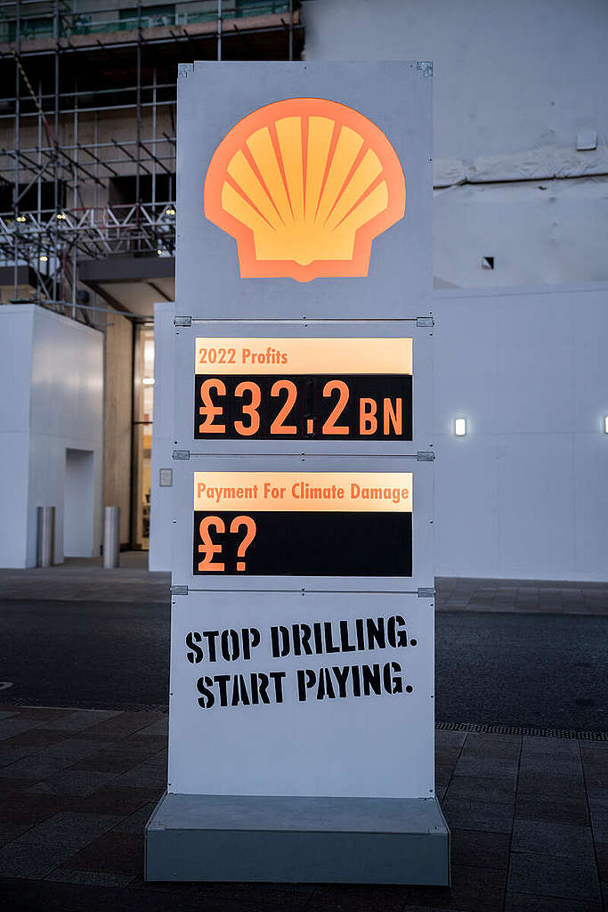
(Image source: David Mirzoeff / Greenpeace)
Appendix B

Match each word in the left column to its most suitable meaning in the right column. Then fill in the blanks with the most suitable word from the left column.

Part 1

detrimental  drought  inequalities  marginalised  multitude  oppression  severe  vital |  |  |  | Absolutely necessary  A large number  Harmful  Unfair differences in opportunities  Extremely serious  Long periods without rain  Pushed to the edges  Prolonged cruel treatment

Part 2

Climate justice is __________ for creating a fairer world. A __________ of studies show that climate change has __________ effects, especially on poor and __________ communities. Rising global temperatures lead to __________ weather events—like floods and __________ —that deepen existing social __________, causing the gap to widen further. These communities, already facing unkind treatment through systemic __________, bear the heaviest burden despite contributing least to the crisis. Addressing climate change must include fighting for equity, or the consequences will only grow worse.

Appendix C

Student | Teacher | Community member | Parent

