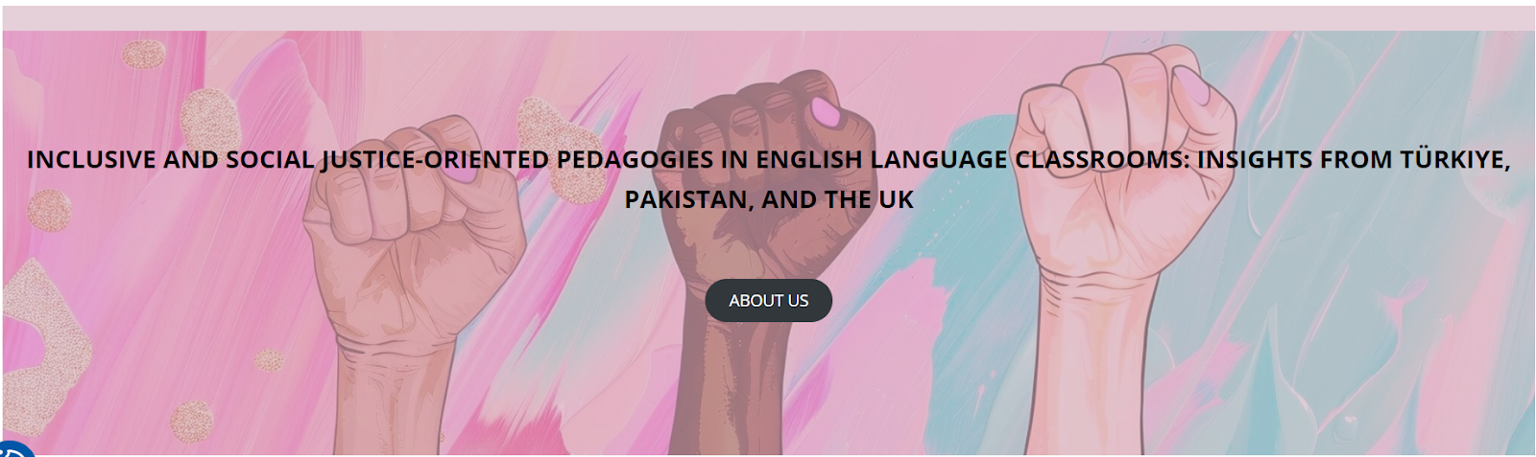

Workshops at the University of Stirling, UK
22-23 February 2025

LESSON PLAN: Danger of a Single Story

School/Institution: University in Colombia
Grade/Level: B2 and above
Language: L1 Spanish / L2 English learners
Course: EAP in psychology, with 12 students in a 60-minute seminar

Rationale Statement
This lesson tackles how oversimplified stories create and reinforce stereotypes—especially about race, gender, and disability. These "single stories" ignore the full reality of people’s lives, often pushing marginalized groups to the sidelines. As psychology students, we need to question who controls these narratives and how they shape attitudes, policies, and even mental health care. By analyzing real-world examples, we’ll see how stereotypes aren’t just harmless assumptions—they have real consequences. The goal is to move beyond just recognising bias and start actively challenging incomplete stories, so we can build a more inclusive perspective in our future work.

Objectives
Content Objectives | Language Objectives
- To understand how single stories shape perceptions and stereotypes. | - To develop listening skills through video analysis.  - To review key vocabulary related to identities (race, gender, disabilities).  - To develop speaking skills through discussions and reflections.
Social Justice Objectives
- To examine how race, gender, and disabilities shape identities and assumptions.
- To critically evaluate how limitations and disabilities are represented in society.
- To challenge stereotypes and biases related to identity.

Procedures
Pre-activities | Time frame | Objective(s) targeted
[Prior to the class, T assigned Ss to watch a video of Chimamanda Ngozi Adichie’s TED Talk, The Danger of a Single Story.]  On a piece of paper, T asks Ss to draw a football player with as much detail as they can.  In small groups, Ss share and describe their pictures, along with any reasons for their drawing.  T asks for some volunteers to share with the whole class.  T summarises common characteristics that Ss drew for the football player.  T shows a picture of the Colombian national football team for blind players (Appendix A).  In pairs, Ss discuss their reflections:  - Did you think a football player could be blind?  - Did you think a blind person could be a football player?  - Why did (almost) everyone in the class have almost the same picture?  Ss share their reflections with the whole class. | 10 mins | To generate interest in the topic and set the scene for the lesson.
T elicits and checks understanding and pronunciation of the following key vocabulary:  - rarest  - contentedly  - occurrence  - disability  - strengthen | 5 mins | To pre-teach key vocabulary needed to help Ss complete the task.
During activities | Time frame | Objective(s) targeted
T distributes a worksheet (Appendix B) for Ss to work on while watching the video.  T explains that they will watch a video of that boy, Ghanim Al-Muftah (without revealing information of his disability).  T asks Ss to read through the worksheet.  In pairs, only based on the picture and the questions, Ss make predictions of possible answers. | 5 mins | To encourage Ss to predict/think about the content of the video.
T shows the video of Ghanim Al-Muftah, who engages in various sports such as swimming, scuba diving, and hiking, despite the medical condition which affects the development of his lower spine.  Ss check their answers with their peers.  Ss share their initial thoughts about the video. | 10 mins | To develop scanning for specific information
In small groups, Ss discuss:  - What can we learn from Ghanim and the blind football players?  - What implications might there be if we only look at things from only a single perspective?  - How can we encourage others (e.g. our patients) to put themselves in others’ shoes and see their perspectives?  Ss share their views with the whole class. | 15 mins | To understand the impact of single stories and practice critical thinking and speaking skills.
Post-activities | Time frame | Objective(s) targeted
T sets up two stations based on the activities suggested in Appendix C.  Ss take turns to do the activities, and then rotates to the other station.  Ss reflect on the lesson in small groups.  - When you were doing those activities, you were disabled in some way. How did you feel?  - Should one be defined by their disability? Why or why not? | 15 minutes | To challenge assumptions and reflect on the lesson.

Resources
- Chimamanda Ngozi Adichie (2009) The danger of a single story | TED. 7 October. Available at: https://youtu.be/D9Ihs241zeg (Accessed: 17 September 2025).
- Paralympic Games (2015) My incredible story by Ghanim Al Muftah. 19 October. Available at: https://www.youtube.com/watch?v=pTcqkGmy9JM (Accessed: 17 September 2025)

Appendix A
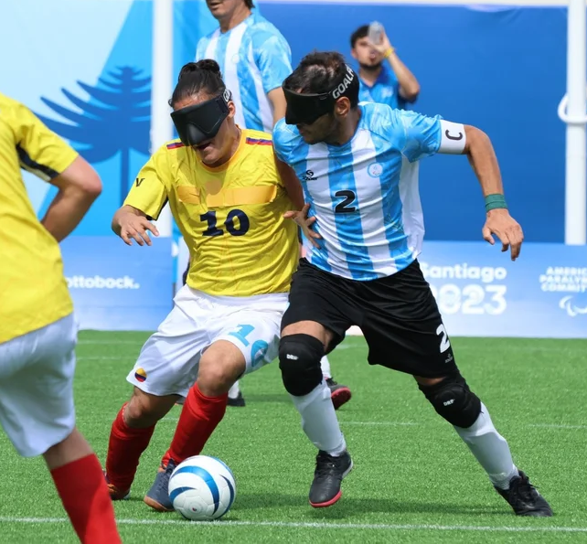
(Image source: The Envisionaries)

Appendix B
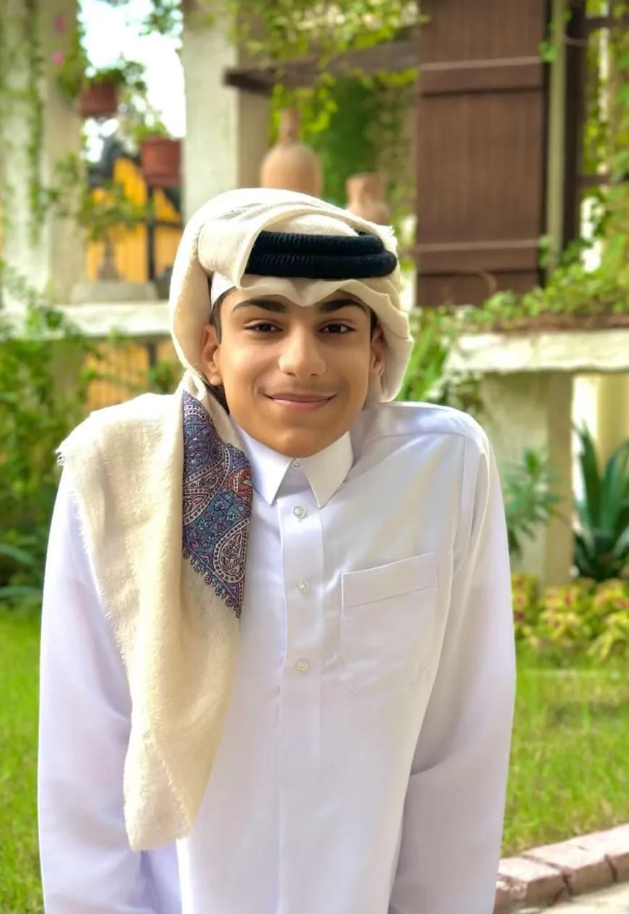
(Image source: MENA Speakers)

Watch the video about Ghanim Al-Muftah and answer the following questions.

- Name three of Ghanim’s favourite sports

- How many followers does Ghanim have on Instagram? __________

- Which medical condition does Ghanim have?
  - Growth Hormone Deficiency
  - Russell-Silver Syndrome
  - Caudal Regression Syndrome
  - Intrauterine Growth Restriction
Appendix C
Teacher chooses two of the following activities to conduct in class:

Activity #1: Dexterity challenge
- Wear thick gloves or mittens, and try to pick up small objects, button a shirt, or use scissors.
- Materials needed:
  - Thick gloves or mittens
  - Shirt with buttons
  - Scissors
  - Small objects like bottle caps, pen, paper, hair tie

Activity #2: Vision impairment exploration
- While using blindfolds, students have to navigate around the classroom or compound. Another student (without blindfolds) can be their guide, either by holding their arms or by giving verbal instructions.
- Materials needed:
  - Blindfolds or large cloths

Activity #3: Hearing impairment game
- Students wear earphones with music blasting in them. Their partner reads out a phrase and they would guess it and write it down.
- Materials needed:
  - Earphones and phone with music player (depending on the context, Ss may be able to provide their own)
  - Small folded strips of paper with random phrases
  - Notebook and pen

Activity #4: Speech difficulties
- Students fill their mouths with water and try to have a conversation with each other (while keeping the water in their mouths).
- Materials needed:
  - Water

