

Workshops at the Trabzon University, Türkiye
11-12 January 2025

LESSON PLAN: Endangered Animals

School/Institution: Public School in Türkiye
Grade/Level: A2
Age: 7–10 (Young Learners)
Language: Multilingual, English as a Second Language
Course: General English
Number of Students: 20
Duration: 60 minutes

Rationale Statement
Endangered animals are a pressing environmental and ethical concern, with factors such as overhunting, pollution, and climate change accelerating species loss. This lesson aims to raise awareness among young learners about the causes and consequences of animal endangerment, and to encourage them to consider practical, age-appropriate actions they can take to protect wildlife. Through multimodal input (visuals, reading, and games) and interactive, collaborative tasks, students will expand their vocabulary, improve their reading comprehension, and practise making suggestions in English. In addition to language skills, the lesson fosters empathy, environmental stewardship, and critical thinking—key competencies for active, responsible global citizenship.

Objectives
Content Objectives | Language Objectives
- To develop understanding on the concept of animal endangerment.  - To identify causes of animal endangerment (e.g., overhunting, pollution, climate change). | - To review and learn key vocabulary related to animals and animal endangerment in both spoken and written contexts.  - To make simple suggestions using target structures (e.g., “We should…”, “I think…”).
Social Justice Objectives
To promote respect for biodiversity and recognise the link between human activity and environmental issues.
To encourage awareness and advocacy of real-world issues.

Procedures
Pre-activities | Time frame | Objective(s) targeted
T announces a game; T pre-teaches key vocabulary (Appendix A) using actions.  Ss mimic T’s actions as they teach.  When T says one of the words/phrases, Ss act them out. When T says “stop,” Ss freeze. Anyone who moves sits down but can still observe or participate from the side.  The game continues until the time is up or until a winner is found. | 12 mins | To introduce and practise key vocabulary through Total Physical Response.  To energise Ss and engage kinesthetic learners.
During activities | Time frame | Objective(s) targeted
T shows photos of endangered animals that could be found in Türkiye (Appendix B) and asks Ss if they know the names of the animals.  Ss shout out their answers.  T says the correct answer and Ss repeat.  T asks Ss what they think is similar between all the animals.  Ss discuss in small groups, then share with the whole class (answer: they are all endangered animals). | 8 mins | To activate prior knowledge.
T asks Ss:  - What are endangered animals?  - What other endangered animals do you know?  Ss raise their hands to answer and T writes them on the board in a mindmap.  In small groups, T asks Ss to provide three reasons why the animals might be endangered.  Ss discuss in their groups and volunteers write down unique answers on the board.  T checks and discusses the answers given. | 12 mins | To introduce the topic in a meaningful context.
Post-activities | Time frame | Objective(s) targeted
T asks Ss “Why should we protect animals?” and “What happens if we don’t?”  Ss raise their hands to answer.  T provides immediate feedback. | 3 mins | To develop critical consciousness on the issue.
In small groups, Ss design a poster about an endangered animal, with a short, memorable slogan. | 18 mins | To reinforce vocabulary and concepts through creative output.
Once completed, Ss display their posters on the walls around the classroom.  Ss walk around, view each other’s work, and give one positive comment per poster. | 7 mins | To practise giving feedback and reflect on others’ ideas.

Appendix A

Hunt: Pretend to be holding an imaginary rifle
Pollute: Cover your mouth or nose
Cut down trees: Pretend to be chopping a tree from the side with an axe
Climate change: Flap hands as if ‘fanning’ yourself
No food: Rub stomach in a circular motion
Protect: Hug your arms tightly around your body

Appendix B

Persian leopard (image source: unsplash.com)
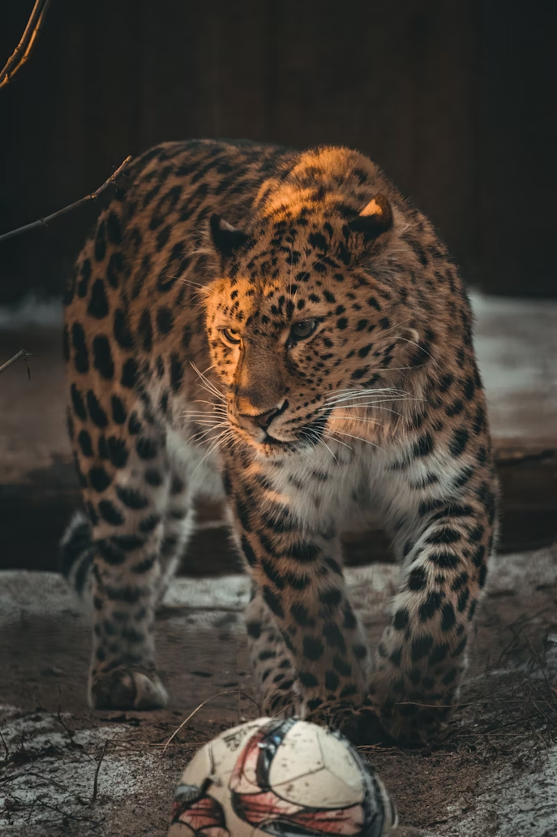

Dhole (image source: Dublin Zoo)
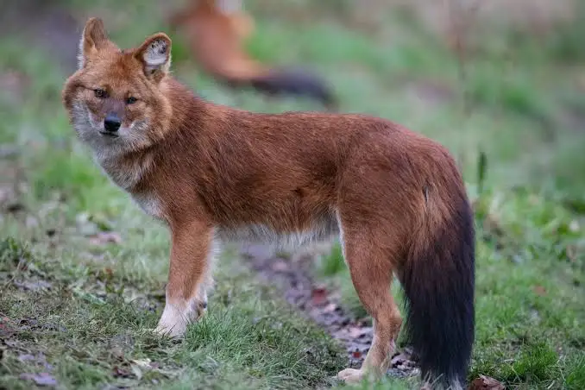

Asia Minor spiny mouse (image source: Prague Zoo)
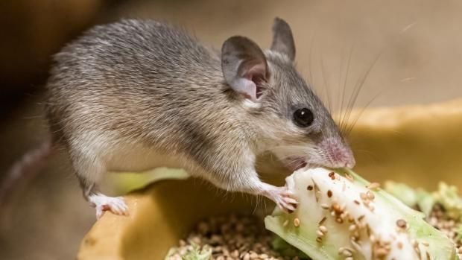

Anatolian Mouflon (image source: Alexander Malkhasyan)
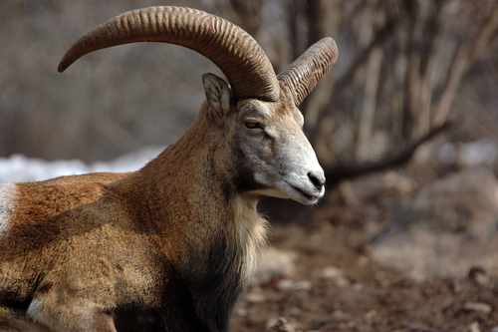

Mediterranean monk seal (image source: Marine Mammal Commission)
