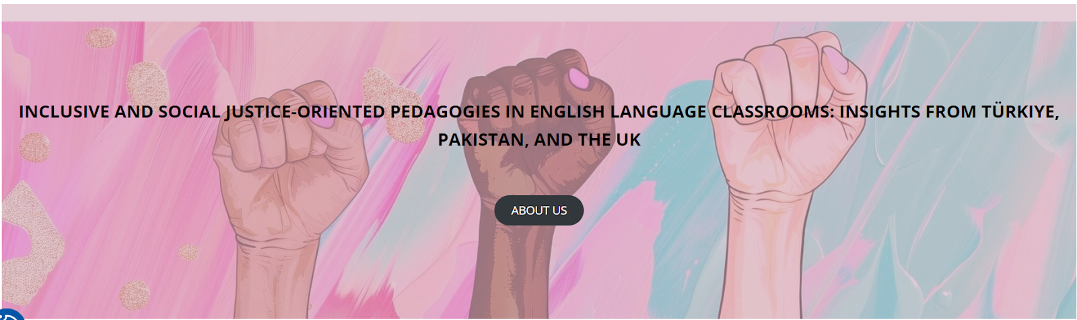

Workshops at the University of Stirling, UK
22-23 February 2025

LESSON PLAN: Feminism in Advertising

School/Institution: EAL class in the UK
Grade/Level: Intermediate aged 15-17
Language: Mixed L1
Course: Feminism in advertising

Rationale Statement
Society is reflective of the media we consume and so when the media endorses and promotes gender stereotypes which are harmful to women, it ensures the perpetuation of sexism and misogyny embedded into the next generation. This lesson plan aims to promote critical analysis of the media students see daily and challenge unconscious biases.

Objectives
Content Objectives | Language Objectives
- To understand about gender norms and stereotypes embedded into advertising. | - To describe visuals using appropriate functional language.  - To share and challenge ideas using suitable phrases related to gender norms and stereotypes.  - To develop speaking skills through discussions and reflections.
Social Justice Objectives
- To examine and challenge gender norms and stereotypes embedded into advertising, perpetuated through the media and society.

Procedures
Pre-activities | Time frame | Objective(s) targeted
T asks Ss to answer on Mentimeter (word cloud):  - What makes a good advertisement? | 3 mins | To generate interest in the topic.
[Prior to the class, T asked Ss to take photos of advert posters or billboards that they see around them, and upload them to Padlet. Adverts should have humans in them.]  T projects the Padlet to the class.  In small groups, Ss discuss about one or two adverts:  - What message is the advertisement trying to convey?  - What are the elements used and what effects do they have on the advertisement or message?  - What do you like or dislike about the advert?  Ss share with the whole class. | 12 mins | To set the scene for the lesson.
During activities | Time frame | Objective(s) targeted
T shares that they will read out a description of an advert, and Ss should try to guess what the advert is about and who might be the producer of it (organisation or brand).  T reads out the description paragraphs in Appendix A while Ss take notes as needed.  T reads it once more.  Ss discuss in pairs about their guesses.  Ss share their predictions with the whole class.  T shows the advert (Appendix B) to the class and asks what they thought of the answer. | 6 mins | To listen to the task done in an authentic manner.
T hands out the worksheet (Appendix A) and asks Ss to complete it.  Ss check their answers with their peers. | 7 mins | To revise any language which may be necessary for the speaking task ahead.
[Prior to class, T hangs the adverts in Appendix C around the classroom.]  Ss are assigned one of the posters to form small groups. Using sticky notes, Ss write down any keywords they thought about the advert and paste next to the advert.  Then, Ss take turns to discuss the advert; they may use the keywords or phrases from the previous worksheet.  Ss rotate to a different advert. They read the keywords already written, and add any others. Again, they take turns to discuss the advert using the keywords or phrases.  Ss rotate for at least one more round. | 12 mins | To give Ss opportunity to prepare before launching into the task.  To develop oral fluency in challenging and critiquing ideas.
Post-activities | Time frame | Objective(s) targeted
T returns to the Mentimeter and asks Ss if they would change or add any keywords.  Ss discuss in pairs then share with the whole class. | 5 mins | To develop Ss’ critical thinking skills.
T asks Ss to choose one of the adverts for them to adapt.  Ss work in pairs to create their adaptation. Ss can draft a new poster visually or make notes on how they would adapt it.  Then, Ss share their ideas with the whole class. | 15 mins | To develop Ss’ critical thinking and encourage advocacy against gender stereotypes in the media.

Appendix A

In this exercise, the underlined phrases can be used either to describe the advertisement, or to challenge stereotypes. Write the underlined phrases in the table based on the correct categories.

This advertisement portrays women as the primary caregivers and homemakers, shown holding babies, supervising homework, and cleaning, while men appear only in supportive or passive roles (e.g., embracing the woman on the sofa). The imagery suggests that domestic and emotional labor falls disproportionately on women, even during a public health crisis. Although the message implies that collective action is needed to protect society, its visual framing undermines this by reinforcing outdated gender roles. The use of these stereotypical scenes reinforces the idea that women are naturally responsible for childcare and housework, while men are not expected to share the burden equally.

This ad is sexist because it erases men’s role in caregiving and normalizes the expectation that women manage both crisis and domestic duties alone. It reinforces harmful gender stereotypes by presenting this imbalance as inevitable rather than a social construct. A more inclusive approach would be to depict men actively parenting (e.g., cooking, teaching, or cleaning) to reflect shared responsibility. Without this, such portrayals could negatively impact society by discouraging boys and men from engaging in caregiving and perpetuating inequality in unpaid labor.

Describing the advert | Challenging stereotypes

Appendix B

(Image source: Bazilik Media)

Appendix C
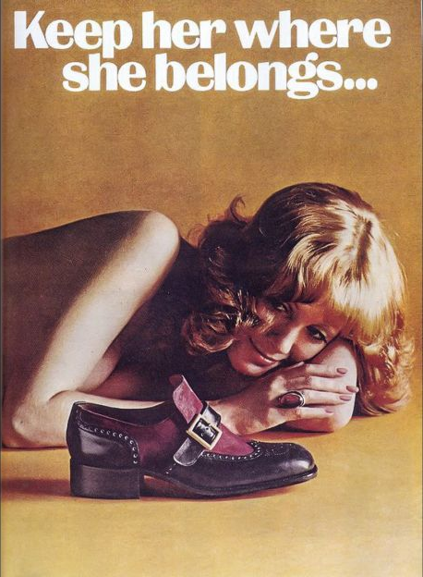
(Image source: The Housewife Modern)

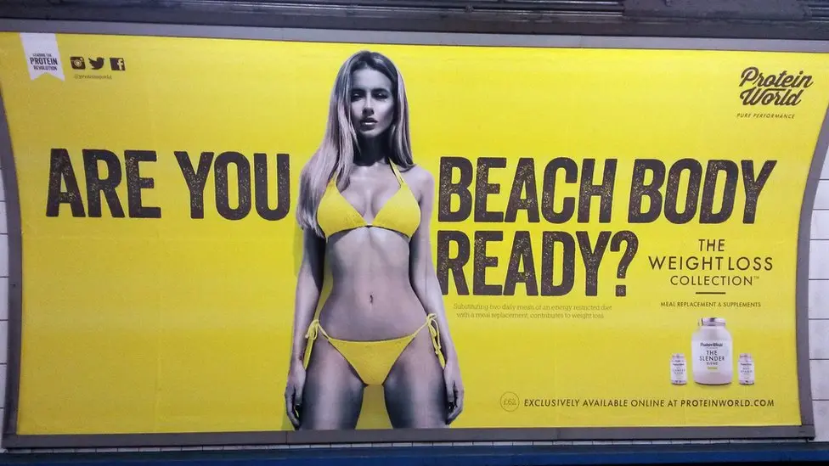
(Image source: BBC News)


(Image source: Bizmalawi on Facebook)

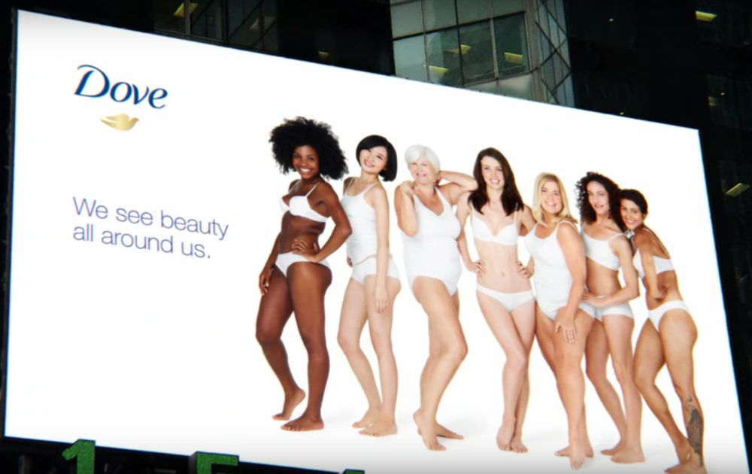
(Image source: Ulster PR Student Blog)


(Image source: Nestlé on msn.com)
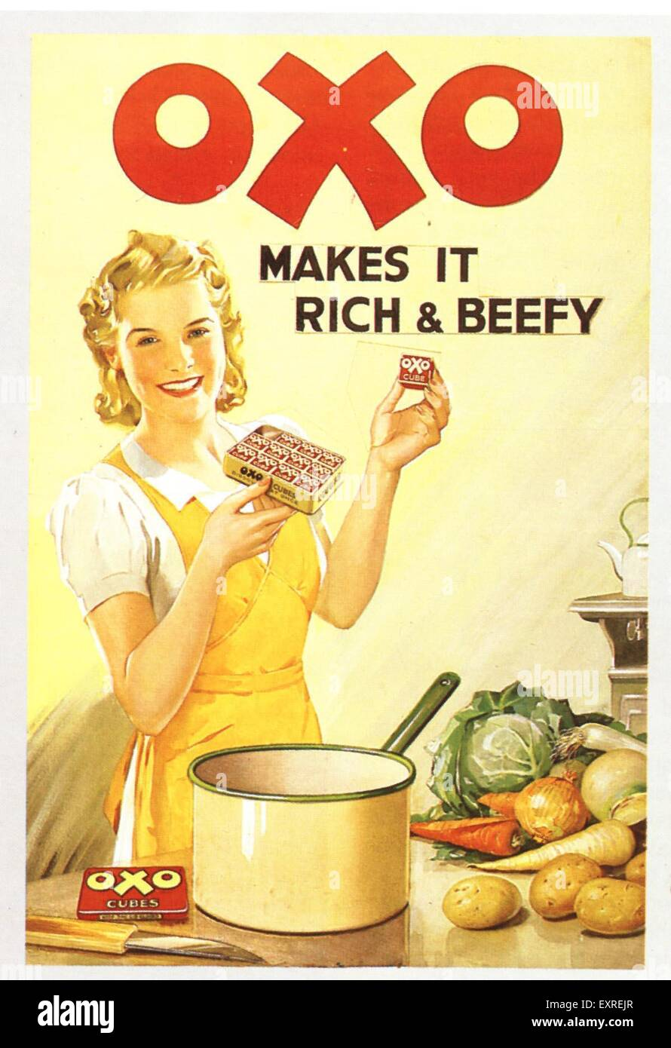
(Image source: alamy)

(Image source: Francesca Formisano on Pinterest)

