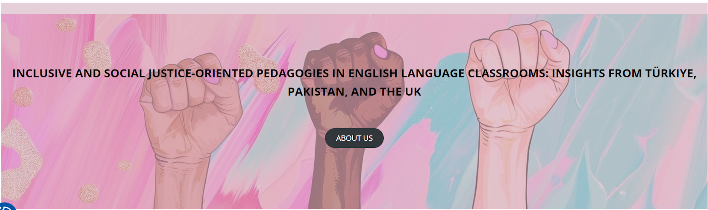

Workshops for Pakistan
1-2 February 2025

LESSON PLAN: Gender Inequality in Education

School/Institution: Govt. Graduate College (W), Gujranwala, Punjab (HED)
Grade/Level: Undergraduate (Second Year)
Course: Expository Writing
Language: L2 English
Topic: Gender Inequality in Accessing Education

Rationale Statement
This lesson plan uses the critical issue of gender inequality in educational access in Pakistan to teach the fundamentals of expository writing. By analysing an article from Human Rights Watch, students engage with authentic, real-world content that provides concrete evidence for their writing. The structured approach—from identifying causes to drafting a focused paragraph—equips them to articulate complex social issues clearly and logically. This method not only builds essential academic writing skills but also fosters critical thinking and civic awareness, empowering students to communicate effectively about significant challenges within their own society.

Objectives
Content Objectives | Language Objectives
- To examine key causes and barriers that led to gender inequality in education in Pakistan. | - To develop writing fluency in expository writing on gender inequality in education.
Social Justice Objectives
- To develop awareness on the issue of gender inequality in education in Pakistan.
- To develop critical consciousness and a focus on solutions or actions.

Procedures
Pre-activities | Time frame | Objective(s) Targeted
T asks Ss to reflect, ‘Did you or anyone you know face challenges in obtaining education or attending school/university?’  Ss discuss in pairs, then share with the whole class. | 10 mins | To generate interest in the topic.
T elicits and checks understanding and pronunciation of the following key vocabulary:  - prohibitive  - compulsory  - discrimination  - harassment  - insecurity | 10 mins | To pre-teach key vocabulary needed to help Ss complete the task.
During activities | Time frame | Objective(s) targeted
T distributes an article on girls’ lack of education in Pakistan, along with an exercise worksheet (Appendix A), where students gather as much information on the causes, along with corresponding examples/details and effects, based on the article.  Ss read the article and fill out the worksheet. | 20 mins | To develop reading skills for identifying different types of information.
T asks Ss to brainstorm on other suitable points to elaborate on the causes or factors identified, especially for any unfilled gaps in the worksheet where information was not found in the article.  Ss continue to work individually.  In pairs, Ss discuss their best three points. | 10 mins | To prepare before launching into a writing task.
T briefly instructs on the general structure of a paragraph in expository writing: topic sentence, supporting details and concluding sentence.  Ss chooses one of the points from the worksheet to draft their own expository paragraph. | 15 mins | To develop fluency in writing.
Ss swap their paragraph with a partner to provide feedback to each other.  Ss make improvements on their paragraphs or attempt to draft for other points. | 10 mins | To allow Ss to provide content and language feedback to one another.
Post-activities | Time frame | Objective(s) targeted
In small groups, Ss discuss potential solutions to promote gender equality in education.  Each group prepares to present one proposed action.  Ss present to the whole class. | 15 mins | To further develop critical consciousness and a focus on solutions or actions.

Resource:
- Human Rights Watch (2018) Pakistan: girls deprived of education: barriers include underinvestment, fees, discrimination. Available at: https://www.hrw.org/news/2018/11/12/pakistan-girls-deprived-education (Accessed: 17 September 2025).

Appendix A

Read the article, “Pakistan: Girls Deprived of Education” by Human Rights Watch, and identify the factors that contribute to the lack of participation of girls in education, along with their corresponding details or evidence, and effects.

Cause/Factor | Detail/Evidence | Effect

