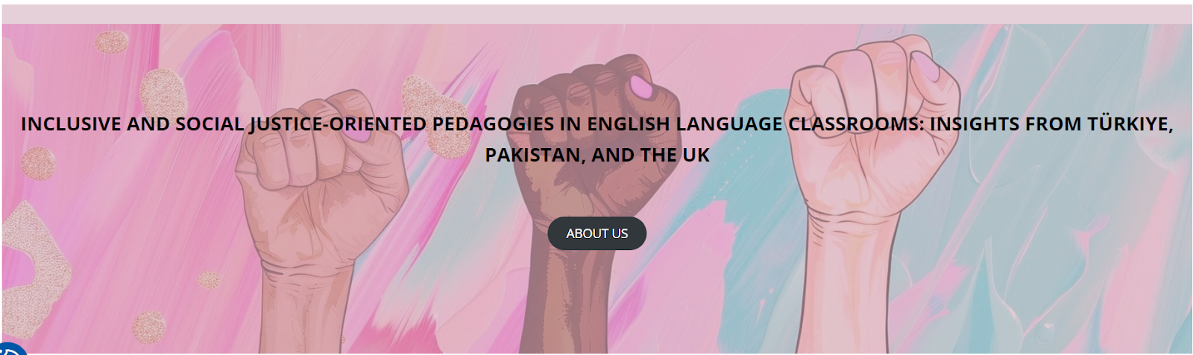

Workshops at Trabzon University, Türkiye
11-12 January 2025

LESSON PLAN: Gender Stereotypes in the Media

School/Institution: Trabzon High School
Grade/Level: 12th Grade – Intermediate
Language: English
Course: English Language
Duration: 60 minutes

Rationale Statement
Media plays a powerful role in shaping societal perceptions of gender. Through advertising, television, and online content, gender stereotypes are often reinforced, influencing how individuals see themselves and others. This lesson encourages students to critically analyse the portrayal of men and women in the media, identify stereotypes, and consider their real-life impacts. Using authentic video material and collaborative activities, students will develop their ability to express opinions in English, practice inclusive language, and reflect on strategies to promote gender equality. In doing so, they will strengthen their language skills while becoming more socially aware and critically engaged citizens.

Objectives
Content Objectives | Language Objectives
- To identify and analyse examples of gender stereotypes in media and everyday language.  - To evaluate the real-life effects of gender bias and discuss possible solutions. | - To express opinions, agreement, and disagreement using target phrases (e.g., I agree/disagree, in my opinion, I think).  - To rewrite gender-biased sentences into gender-neutral forms.
Social Justice Objectives
- To recognise the impact of gender inequality on individuals and communities.
- To promote inclusive language use and challenge harmful stereotypes in communication.

Procedures
Pre-activities | Time frame | Objective(s) targeted
Using Mentimeter or a quick hands-up poll, Ss respond to the question: Do you agree that the media shows men and women equally?  T records results.  T notes the phrase ‘I agree/disagree because…’ at the side of the board and encourages Ss to use it.  Ss volunteer to elaborate on their opinions. | 3 mins | To activate curiosity and interest in the topic.
T writes the question What does gender equality mean to you? on the board.  T notes the phrases ‘In my opinion…’ and ‘I think…’ at the side of the board and encourages Ss to use them.  Ss brainstorm in small groups.  Ss share ideas to create a class mind map. | 7 mins | To set the scene for the lesson.
During activities | Time frame | Objective(s) targeted
T shows a video of male athletes being asked questions targeted at female athletes.  Ss take note of the stereotypes that are present.  T shows the video again.  In pairs, Ss reflect on the following questions:  - What stereotypes are present?  - How could this affect viewers?  Ss share with the whole class. | 15 mins | To develop listening skills for detailed comprehension.  To develop critical thinking skills to identify bias.
In small groups, Ss discuss the following question:  - Do you see similar examples in your culture?  Ss share with the whole class. | 10 mins | To respond to the topic in a personal way.
Post-activities | Time frame | Objective(s) targeted
T presents a few sentences that contain gender-biased terms (Appendix A) and asks Ss to identify the bias and rephrase them to be more gender-neutral.  Ss work with a partner.  Two pairs form small groups to provide peer feedback to each other.  Ss discuss with the whole class. | 20 mins | To develop critical consciousness and apply inclusive language skills in context.
Individually, Ss complete an exit ticket with:  1) One stereotype they noticed today.  2) One change they will make in their own language use. | 5 mins | To promote reflection and personal commitment to inclusive language.

Resource
- BellTime Mag (2016) If male athletes were asked questions aimed at female athletes. 10 February. Available at: https://www.youtube.com/watch?v=3aT32m6UH7E (Accessed: 17 September 2025).

Appendix A

With a partner, read each sentence. Discuss the gender bias or stereotype it contains. Then, rewrite the sentence to make it more inclusive and gender-neutral.

- Every student should have his notebook ready for the inspection by the headmaster.
- We are looking for a new chairman for the school's science club.
- The firefighters bravely fought the blaze, and we should all thank them for their manhood and courage.
- The nurses and their husbands are invited to the annual hospital gala.
- The ambitious businessman and his stylish wife attended the charity auction.
- The girls in the class are so emotional, but the boys are very logical during debates.
- We need a few strong men to help move the heavy furniture tomorrow.
- The pioneering female engineer finally received the recognition she deserved.

Additional notes for the teacher:

- Every student should have his notebook ready for the inspection by the headmaster.
Target Bias: Uses the default masculine pronoun for a mixed-gender group.

- We are looking for a new chairman for the school's science club.
Target Bias: Uses a gendered term for a neutral position.

- The firefighters bravely fought the blaze, and we should all thank them for their manhood and courage.
Target Bias: Equates courage and bravery exclusively with masculinity.

- The nurses and their husbands are invited to the annual hospital gala.
Target Bias: Assumes all nurses are women and are in heterosexual relationships.

- The ambitious businessman and his stylish wife attended the charity auction.
Target Bias: Stereotypes the man by his profession and the woman by her appearance and relationship to him.

- The girls in the class are so emotional, but the boys are very logical during debates.
Target Bias: Perpetuates a common stereotype about emotionality versus logic being tied to gender.

- We need a few strong men to help move the heavy furniture tomorrow.
Target Bias: Assumes that only men are strong and that physical labor is a male task.

- The pioneering female engineer finally received the recognition she deserved.
Target Bias: While well-intentioned, using "female" as a modifier can be seen as othering, implying that being an engineer is an unusual state for a woman.

