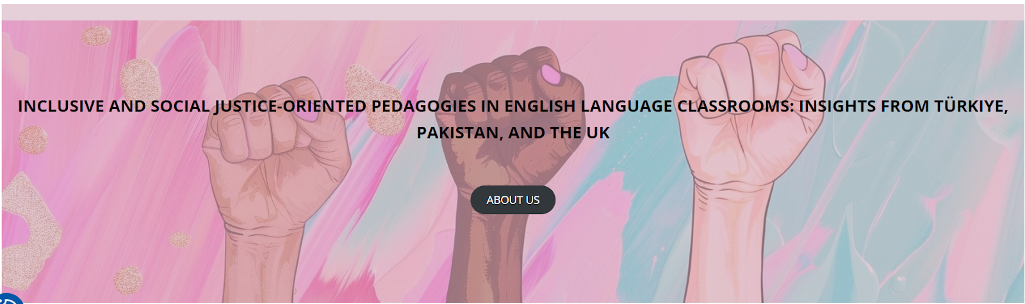

Workshops for Pakistan
1-2 February 2025

LESSON PLAN: Inclusive Communication in the Hotel Industry

School/Institution: Govt. Graduate College (W), Lahore (HED)
Grade/Level: BS (Second Year)
Language: L2 English
Course: English for Occupational Purpose (EOP)

Rationale Statement
This lesson is critically relevant for future hospitality professionals as global travel intensifies. It moves beyond basic English to teach the nuanced, respectful language required to serve all guests effectively, regardless of their background, ability, or identity. By focusing on inclusive communication, students learn to avoid assumptions that can cause offense, ensuring every guest feels welcome and valued. This directly enhances customer satisfaction, positive reviews, and employability in international hotel brands that prioritise Equity, Diversity, and Inclusion (EDI) as a core business standard, not just a social concept.

Objectives
Content Objectives | Language Objectives
- To understand potential communicative issues that may arise in the hospitality industry.  - To be able to communicate effectively and respectfully with all guests, staff, and management. | - To review key vocabulary related to hospitality and service within context.  - To develop oral communication skills through discussions, roleplays and reflections.
Social Justice Objectives
- To provide equal and equitable opportunities regardless of gender, race, ethnicity, or language.
- To foster inclusive communication across diverse cultures.

Procedures
Pre-activities | Time frame | Objective(s) targeted
T shows pictures of diverse people (refer to Appendix A for examples).  T asks: “What do all these people have in common?” (Answer: They are all potential hotel guests who deserve excellent, respectful service). | 5 mins | To generate interest in the topic.
In pairs, Ss discuss:  - What does it mean to be inclusive?  - Have they or anyone they know experienced situations where they did not feel welcomed or respected?  Ss share with the whole class. | 10 mins | To set the scene for the lesson.
During Activities | Time frame | Objective(s) targeted
T distributes a list of brief scenarios that may contain non-inclusive language (Appendix B).  In small groups, Ss identify the problem and rewrite the dialogue to be more inclusive. | 15 mins | To develop awareness of uninclusive misconduct in the hotel industry.
T moderates a forum theatre-style roleplay.  Ss volunteer to perform the role play based on each scenario. Other Ss may interrupt the play and resume the roles whenever they feel they could suggest a better dialogue.  After each scenario has been performed, Ss briefly reflect on the activity. | 15 mins | To develop communicative competence and problem-solving skills.
Post-activities | Time frame | Objective(s) targeted
T presents the following scenario:  ‘You are the owners of a hotel. What key principles every hotel employee should practise to ensure guests feel welcomed and respected?’  Ss discuss in small groups and make notes.  Ss shares their group ideas with the whole class.  T writes each unique idea on the board.  As a whole class, Ss decide on three key principles that are most important. T moderates if needed. | 15 mins | To further personalise the topic and allow opportunity for productive practice.

Appendix A
(Images sourced from unsplash.com)
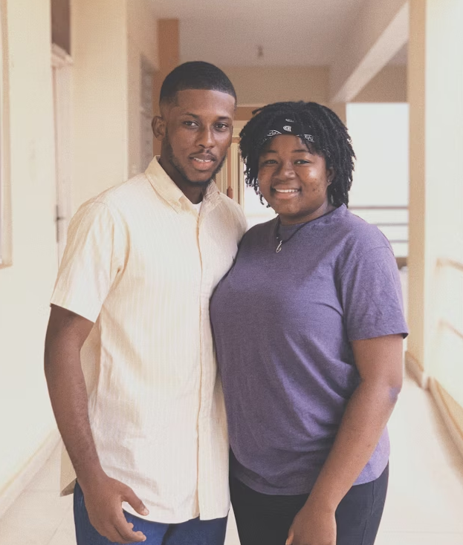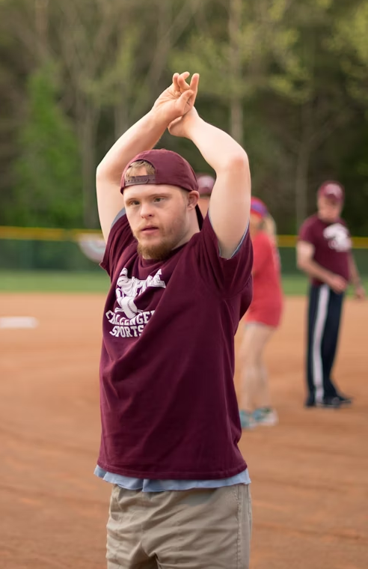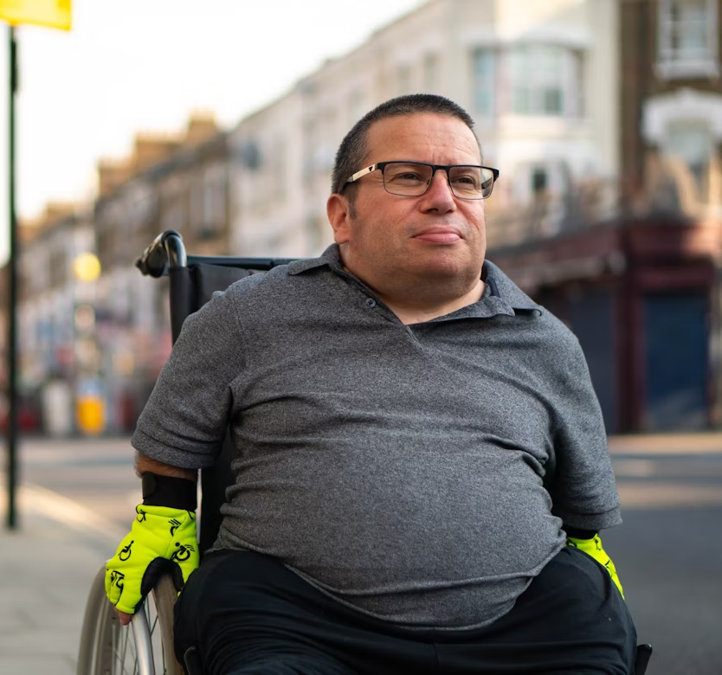

Appendix B
Read each scenario and discuss how it may be rewritten to be more inclusive, respectful and professional.

Scenario 1: The Family Reservation
Situation: A woman is checking in with a young boy.
Staff says: "Hello, Mrs. Ahmed. Welcome! I see you've brought your son. We have a lovely kids' activity pack for him."

Scenario 2: The Accessible Room
Situation: A guest using a wheelchair is checking into a room they specifically booked for its accessibility features.
Staff says: (In a sympathetic tone) "Oh, it's so wonderful to see you getting out and traveling! We've put you in one of our special rooms on the ground floor."

Scenario 3: The Dietary Question
Situation: A server is taking orders from a table of guests with diverse appearances.
Server says: (To a guest who appears to be of European descent) "I should let you know, the curry is actually quite spicy. We also have milder options available."

Scenario 4: The Friendly Assumption
Situation: Guest (a man) arrives with another man.
Front desk agent says: "Welcome, sir. Is your friend checking in too?"

