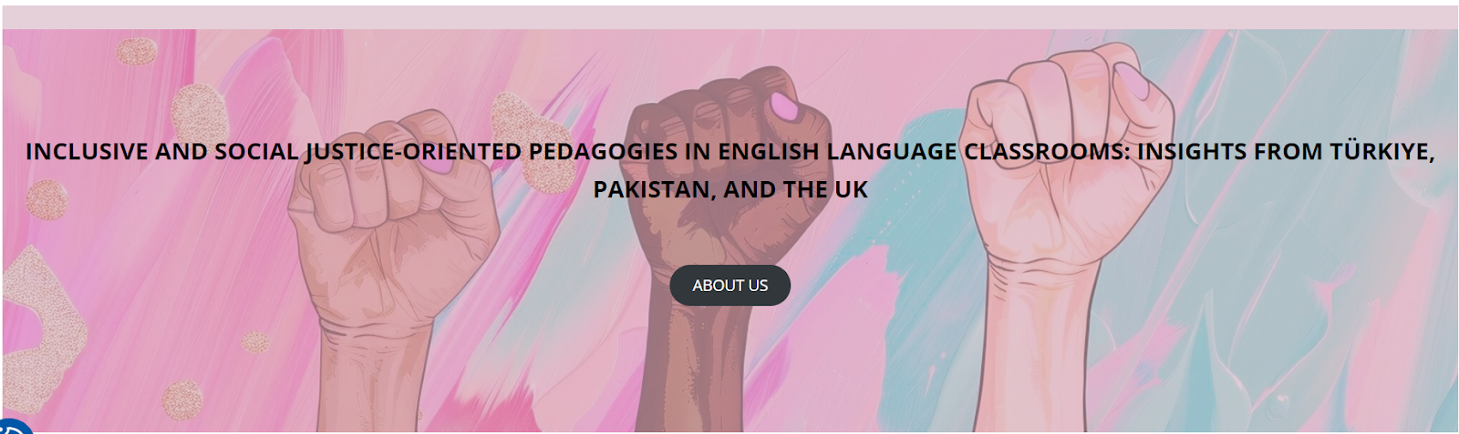

Workshops at the University of Stirling, UK
22-23 February 2025

LESSON PLAN TEMPLATE

School/Institution: Public school in China
Grade/Level: A1–A2
Age: 7–10 (Young Learners)
Language: Multilingual, English as a Second Language
Course: General English
Number of Students: 15
Rationale Statement
In many Chinese textbooks, different types of non-traditional families—such as same-sex or single-parent families—are often excluded. This lesson introduces learners to diverse family structures through an engaging, age-appropriate story about animals, encouraging acceptance and respect for all family types. The context of the lesson allows young learners to develop vocabulary related to family, and in expressing possessions using ‘has’ or ‘have’, while also building empathy and understanding of diversity.

Objectives
Content Objectives | Language Objectives
- To understand the concept of family and different family types through a narrative. | - To develop listening for specific information in a story about family.  - To use ‘has’ or ‘have’ accurately in showing possession or belonging.
Social Justice Objectives
- To develop awareness of non-traditional family structures.
- To promote respect and acceptance of diversity in family structures.

Procedures
Pre-activities | Time frame | Objective(s) targeted
T plays the Baby Shark song and invites Ss to stand up, sing and dance along.  T repeats the song if Ss seem enthusiastic. | 5 mins | To energise Ss and engage kinesthetic learners.
T shows a picture of the Shark family (Appendix A).  T points at each character one at a time, and asks Ss to shout out its name.  Using the picture and gesturing togetherness, T elicits the words ‘family’, ‘love’ and ‘home’.  T elicits other family members that Ss know (e.g., sister, brother, cousin) and writes them on the board.  T demonstrates, e.g. “In my family, I have a mommy, a daddy, two sisters and a brother.”  T asks CCQs:  - Do I have a daddy?  - Do I have a mommy?  - How many sisters do I have?  - How many brothers do I have?  In pairs, Ss share about how many family members they have. | 8 mins | To set the scene for the lesson.
During activities | Time frame | Objective(s) targeted
T announces that they will watch a story about a different family.  T shows the video of ‘And Tango Makes Three’.  T asks Ss to complete the exercise in Appendix B.  Ss conduct a brief peer-checking.  T shows the video a second time.  Ss complete the exercise, if needed, and peer-checks again. | 15 mins | To introduce vocabulary within context.  To develop listening skills for specific information.
T displays the picture in Appendix C and asks CCQs:  - What kind of animals are they?  - What are the names of the big penguins?  - What is the name of the baby penguin?  T displays the pictures from Appendices A and C side by side, and asks CCQs to compare:  - Does Baby Shark have a mommy? / Does Tango have a mommy?  - Does Baby Shark have a daddy? / Does Tango have a daddy?  - How many ‘mommies’ does Baby Shark have? / How many ‘mommies’ does Tango have?  - How many ‘daddies’ does Baby Shark have? / How many ‘daddies’ does Tango have?  - Do they (sharks) love each other? / Do they (penguins) love each other?  - Are they (sharks) a family? / Are they (penguins) a family?  Ss shout out their answers. | 5 mins | To assess Ss’ understanding of the concept introduced.
Post-activities | Time frame | Objective(s) targeted
T asks Ss to share more about their family members by completing the exercise in Appendix D.  Ss work individually at first.  Ss check their answers with a partner.  Ss volunteer to share some of their sentences with the whole class. | 12 mins | To further personalise the target language.

Resources
- Pinkfong (2016) Baby Shark dance. 18 June. Available at: https://www.youtube.com/watch?v=XqZsoesa55w (Accessed: 17 September 2025).
- Simon Kids (2016) And tango makes three. 16 September. Available at: https://www.youtube.com/watch?v=4uOXUCiDE-s (Accessed: 17 September 2025).

Appendix A

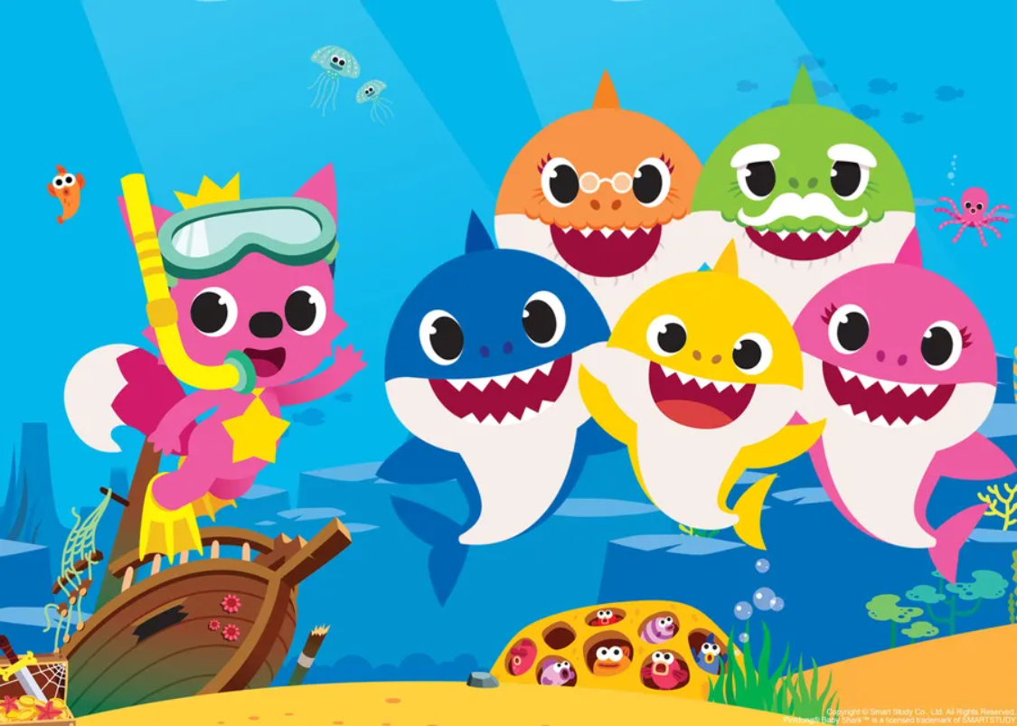
(Image by vakl82 from wallpapers.com)

Baby shark | Mommy shark | Daddy shark | Grandma shark | Grandpa shark

Appendix B

Match the pictures with the most suitable word from the list provided.
penguin | nest | baby | rock | egg

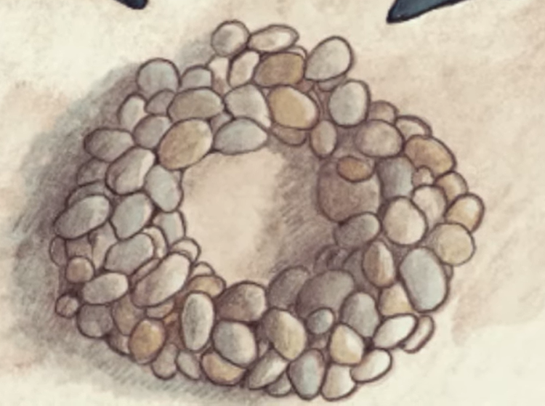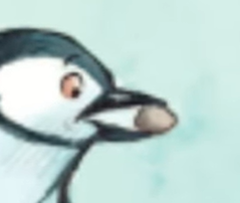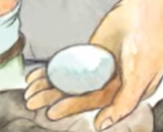

_____________________ _____________________ _____________________

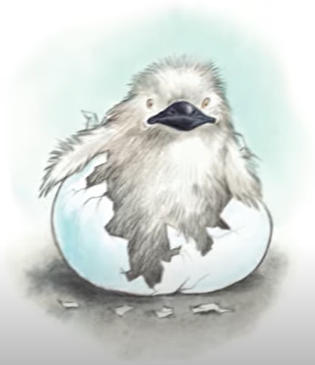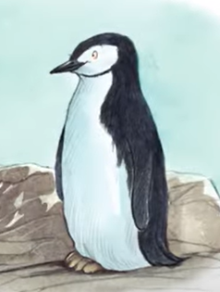

_____________________ _____________________

(Images sourced from Simon Kids on Youtube)
Appendix C

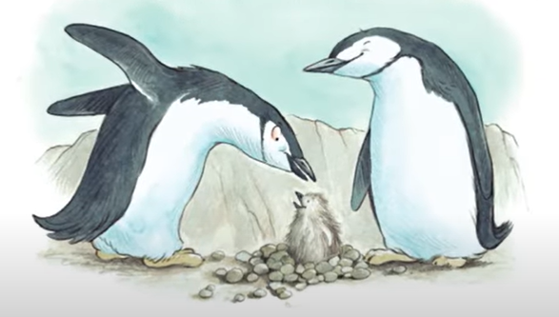
(Image sourced from Simon Kids on Youtube)

Appendix D
Build sentences using ‘has’ or ‘have’ to talk about your family members.
E.g., My daddy has a big house.
My sister has ten pencils.
My brothers have a fun video game.

