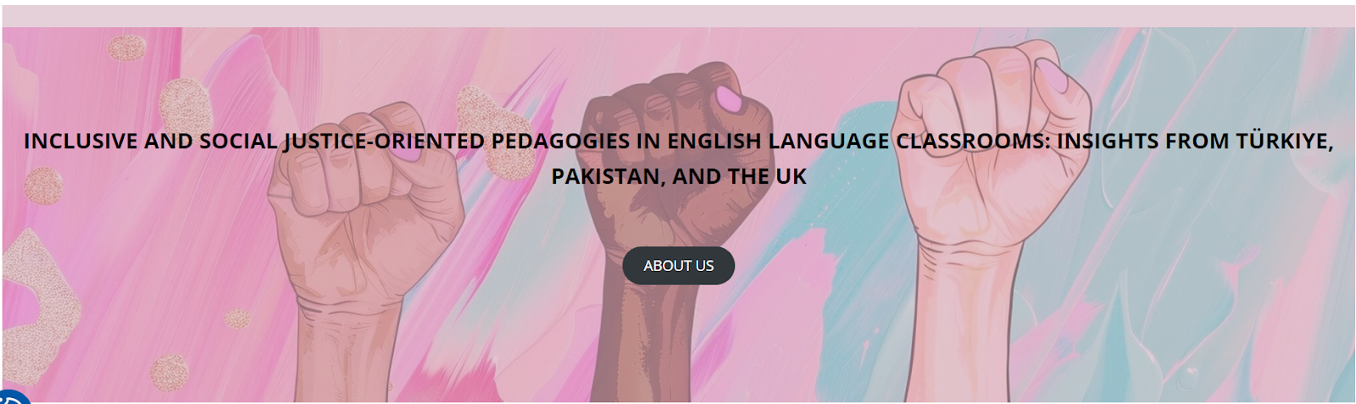

Workshops at the University of Stirling, UK
22-23 February 2025

LESSON PLAN: Rights to Learn and Live

School/Institution: Private Language School in China
Grade/Level: Teenagers (ages 15-18)
Language: English (B1-B2 Level)
Course: General English - 60 mins lesson

Rationale Statement
This lesson uses the urgent plight of Afghan women students to confront core issues of social justice: systemic gender oppression, the right to education, and the global inequity of freedom of movement. The article challenges students to critically examine the responsibilities of governments and individuals in upholding human rights across borders. By analysing the barriers within resettlement schemes, students engage with the complex realities of international justice, shifting from just talking about fairness to the actual process of fighting for it and the fundamental belief that everyone deserves a safe haven.

Objectives
Content Objectives | Language Objectives
- To understand about a real-world humanitarian issue around refugee resettlement and education rights, and how it affects individuals worldwide. | - To develop critical reading skills.  - To develop reading skills in predicting and scanning for specific information.
Social Justice Objectives
- To develop critical thinking skills in evaluating different perspectives on access to education and the responsibilities of governments and institutions.
- To understand how education inequality affects marginalised groups and discuss potential policy solutions.
- To explore actions that individuals and communities can take to support refugees and advocate for equal educational opportunities.

Procedures
Pre-activities | Time frame | Objective(s) targeted
T greets Ss and asks if they are close with their neighbour and how they have provided any help to them.  In pairs, Ss discuss:  - Would you help your neighbour in these situations:  - Give them food to eat  - Let them stay at your house if something happened to theirs  - Pay for their studies if they cannot afford it  Ss share their opinions with the whole class. | 5 mins | To generate interest in the topic in a personal way.
In small groups, Ss discuss  - In what ways have their local council or government provided help to people outside of the locality or outside of the country?  Ss share their discussion with the whole class. | 5 mins | To set the scene for the lesson.
T elicits and checks understanding and pronunciation on the following vocabulary:  - Charity  - Priority  - Chaperone  - Strict  - Framework  - Accommodate | 8 mins | To pre-teach key vocabulary needed to help Ss complete the task.
During activities | Time frame | Objective(s) targeted
T displays the title of the article “Scots aid worker charity in bid to help 20 Afghan students” on the screen.  In pairs, Ss make predictions of what they think the article is about.  Ss share their predictions and T asks representatives to note them down on the board. | 5 mins | To encourage Ss to predict/think about the content of the text.
T distributes the text and questions.  T asks Ss to underline or highlight answers to the following questions:  - When was Linda Norgrove kidnapped?  - What was the role of the Linda Norgrove foundation?  - What were the impacts of Taliban rule on women’s rights in Afghanistan?  - What challenge did the foundation face in trying to bring the students to Scotland?  - How did the UK government plan to help the Afghan medical students?  - What happened to Linda Norgrove during the rescue attempt?  Ss compare answers in pairs.  T provides the answer scheme and addresses any problematic questions. | 17 mins | To develop scanning for specific information.
Post-activities | Time frame | Objective(s) targeted
Ss read the article again and note their answer to the question:  - Why was the UK government keen on helping the Afghan medical students?  Ss discuss their answers in small groups, along with the following questions:  - Do you agree with the actions of the UK government? Why or why not?  - Would the Chinese government do the same, or help the Afghan medical students in any way? Please explain.  Ss share their discussion with the whole class. | 20 mins | To develop Ss’ critical reading skills.  To respond to the text in a personal way.

Resource
- BBC News (2023) ‘Scots aid worker charity in bid to help 20 Afghan students’, 10 September. Available at: https://www.bbc.co.uk/news/uk-scotland-highlands-islands-66754315 (Accessed: 16 September 2025).

